

Assessment Workgroup

ASSESSMENT OBJECTS PLAN

June 2, 2006

Draft Document Version Control
Version | Date: | Author/Organization: | Comments
1.0 | 01/13/2006 | Kris Herakovich | 1st Draft
1.1 | 2/19/06 | Vince Paredes
1.2 | 2/20/2006 | Workgroup in Orlando
1.3 | 2/21/2006 | Workgroup in Orlando
1.4 | 3/7/2006 | Kris, Vince, Theo, DeAnna | Review during a regular call.
1.5 |  | DeAnna | Added examples to tables.
1.6 |  | Vince | Worked in edits from last call and Orlando meeting.
1.7 |  | Vince | Edited and added content to object designs.
1.8 | 4/27/2006 | Jill Abbot, Kris Herakovich, Vince Paredes, Sean Palmer | Work done at the Chicago meeting. Incorporated feedback from conference and test plan creation process.
1.10 | 5/4/2006 | Vince Paredes, Kris Herakovich, Jill Abbot | Edits based upon Chicago feedback and via the discussion group.
1.11 | 6/2/2006 | Vince Paredes | Changes from comments during voting period.

Table of Contents

1 Business Case 5
1.1 Business Cases for Interoperability 5
1.2 Types of Assessments 6
1.2.1 Formative Assessment 6
1.2.2 Summative Assessment 6
1.3 Assessment Delivery and Reporting Scenarios 6
2 Defined Terms 8
3 Detailed Object Dependencies 10
3.1 Use Case 1: Teacher administers a teacher-made paper and pencil assessment 11
3.2 Use Case 2: Teacher administers a teacher-made online assessment 12
3.3 Use Case 3: An assessment with test accommodations 14
3.4 Use Case 4: Test is interrupted by an unexpected event 15
3.5 Use Case 5: Administering a state level standard assessment 16
3.6 Use Case 6: Receiving score reports from an assessment 18
3.7 Use Case 7: Administering an assessment online 19
4 Detailed Object Changes 21
5 Detailed Infrastructure Changes 21
6 Object Descriptions 22
6.1 Assessment Object 22
6.1.1 Assessment Container Object 22
6.1.2 ReportAuthorityInfo 23
6.1.3 ReportManifest 24
6.1.4 ReportData 24
6.1.5 ContentPackageData 24
6.1.6 SIF_Metadata 25
6.2 AssessmentAdministration Object 26
6.3 AssessmentForm Object 29
6.4 AssessmentRegistration Object 31
6.5 AssessmentSubTest Object 33
6.6 StudentResponseSet Object 36
6.7 StudentScoreSet Object 38
7 XML Schema 40
8 XML Examples 41
8.1 Assessment Object 41
8.2 AssessmentAdministration Object 41
8.3 AssessmentForm Object 41
8.4 AssessmentRegistration Object 42
8.5 AssessmentSubTest Object 42
8.6 StudentResponseSet Object 43
8.7 StudentScoreSet Object 43
9 Time Line 44
10 Appendix A: XML Diagram Symbol 45
11 Appendix B: SIF Characteristic Codes 46
12 Appendix C: XML Data Types: 47

Business Case

Business Cases for Interoperability

- Teachers create their own (teacher-made) assessments to ensure that students are meeting instructional goals. These assessments can be implemented using automated software systems or using traditional paper tests and quizzes. Teachers or other local level assessment constructors must be able to access items and construct assessments (Item collections or assessment forms) using software systems that allow the use of items stored within a local or regional repository. In addition, test makers should be able to use tools to create new items that can then be conveyed using delivery systems (Both electronic and paper.)
- Teachers, in order to fully assess the progress of their students and to intelligently develop individualized instruction, must be able to access results of multiple assessments for their students. This information should be current and historical, and should include results from standardized as well as teacher-made assessments. Test may be administered in an online format or by paper and pencil.
- Schools, districts, states, and the federal government administer standardized tests in order to measure student progress in a valid and consistent way and to report on the effectiveness of schools, programs and curriculum. The responses to items on these assessments must be communicated to scoring service providers. Responses can take various forms such as multiple choice responses, essays, and digitized examples of student work. Test results that have been interrupted by an unexpected event, must be addressed. Student responses to items on tests are transformed into scores or assessment results. These assessment results in aggregate or individual form must be communicated among all stakeholders including students, parents, teachers, the public, schools, districts, states, and the federal government.
- Teachers must communicate the results of teacher-made assessments to students, parents, the school and the district. These assessment results must also be used to adjust instruction, to help align instruction with curriculum and to link learning resources through alignments to learning standards.
- Test administrations must be available with accommodations for all students who qualify for a different form of a test, a unique presentation of questions, and other accommodations.
- Local and state education agencies receive standardized test results to assess teacher effectiveness and enhance teacher professional development activities.
- Results from assessments become important indicators for parents on the progress and competence of their children. Results are also used by the broader public and the press to evaluate the performance of educational institutions (schools, districts, states).

Types of Assessments

The uses of assessment in PK-12 education are broad, and growing, particularly with the added awareness of measurement prompted by NCLB. Below is a summary of the types of assessments that could be used in PK-12. They are organized into two categories: Formative Assessments and Summative Assessments.

Formative Assessment

- Benchmarking/Pre-test/Post-test – Solutions that measure student’s prior knowledge and skill sets, as well as progress over time.
- Quizzes and classroom assessments– Regular and periodic measures in the classroom, typically addressing specific topics immediately after a section of instruction.
- Diagnostic – Assessments that identify specific skills mastery and deficits.
- Prescriptive – Much like diagnostic testing, prescriptive solutions add the ability to recommend specific interventions and remediation/acceleration for individual students.
- Predictive – Formative measures with statistically valid indications of likely performance on large-scale summative “high stakes” tests.

Summative Assessment
- Norm referenced assessment
- Criterion referenced assessment
- State-wide accountability assessment
- Item or stage-adaptive assessment

Assessment Delivery and Reporting Scenarios

Scenarios for the delivery and reporting of assessments are listed next. Each one is important when considering business and use cases for interoperability.

- On-line/electronic administration.
- Traditional "paper and pencil" administration.
- On-line reporting of results.
- Multi-vendor engagement (One vendor developing the test, another administering the test and still a 3rd reporting).
- Mixed or hybrid administration.
- Review of items and tests in development.
- Pilot testing of items in development (To generate item statistics and parameters)
- Home grown reporting scenarios, i.e. purchase of software and download data from reporting vendor.

Defined Terms

Assessment Administration The administration represents a testing event. The event may be spread out over time. This container holds information specific to the test taker and conditions surrounding the administration of the assessment required to properly interpret and score responses.

Assessment A set of questions or exercises in a test or evaluative instrument.

Assessment Form This object will distinguish between tests of the same subject area that have questions in a different order, different questions, or a different format, but that will be scored for the same result.

Assessment Item This object represents an individual question or exercise in a test or evaluative instrument.

Assessment Registration This object represents the assignment of a student to a particular test or activity. This is commonly used to determine test accommodations in advance of the administration of the test. It is also used to prepare test materials or test administration capacity.

Assessment Section A set of items or questions. This grouping is for presentation of the items and not scoring.

Response The student work produced by an assessment or activity in raw form.

Rubric The scoring guidelines for evaluating student work to produce a score. (American definition)

Score Subtest score or total. The evaluation of student work produced by an assessment or activity in scored form.

Special Conditions Unexpected special conditions by (individual and/or by administration) related to the administration of the test. Individual example: student became ill during test. Administration example: test was interrupted by a fire alarm.

Subtest Operationally, subtests are the scores available from a test. A subtest is the type or class of scores on an assessment. The score is a psychological construct measured by the assessment. Some assessments may have only one subtest or type of score but most assessments measure more than one psychological construct. The subtest can be based upon items in a section or items that are empirically related. Subtests can also be composites of other subtests that are combined using a particular algorithm. Examples of subtests of an assessment are math total, reading composite, total test, English composition.

Test Accommodations A predefined condition (by individual) that relates to the administration of the test, e.g. extended time, use of a calculator, Braille test materials, untimed administration, etc.

Detailed Object Dependencies

This picture represents a high level view of the information model proposed by the Assessment Work Group including references and dependencies with other SIF and proposed objects.

The TestAccommodation object below is a shared interest object being developed by the Special Programs Workgroup. Shaded objects are proposed objects or elements being developed by the Assessment Workgroup. The other unshaded objects are existing SIF objects or proposed SIF objects.

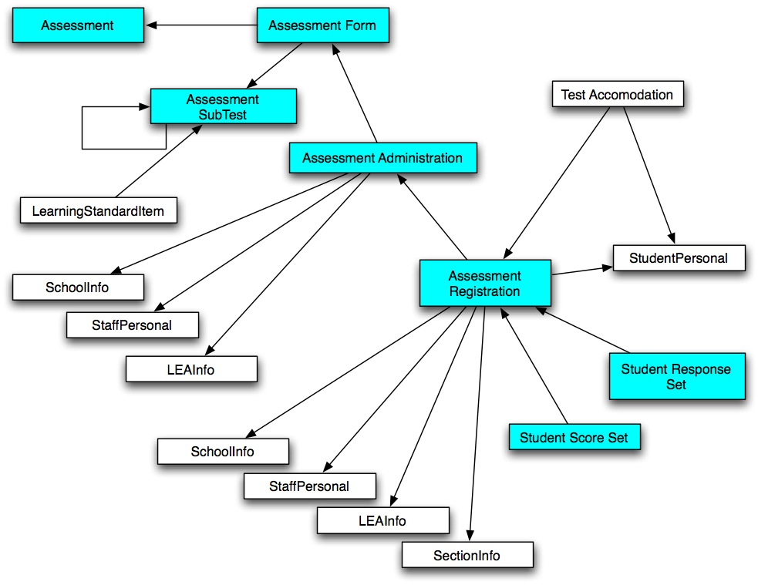

Use Cases

Use Case 1: Teacher administers a teacher-made paper and pencil assessment

SIF Working Group: Assessment | Title: Teacher administers a teacher-made paper and pencil assessment  Use Case Number: Assessment – 1  Status: Draft  History: Created by Kris Herakovich - October 28, 2005  Refine use cases  Approved by Assessment Group  Changes to new format  Changes made and approved by Assessment Group
Use Case Type | Mandatory Use Case
SIF Version and References | SIF Implementation Specification Version 2.0  Assessment Working Group
Actors | Primary: Teacher  Secondary: Software and Student
Preconditions set to simplify scenario | Student is enrolled in the teacher’s class and is assigned to that teacher.
Summary | A teacher develops an assessment that uses paper and pencil. The assessment is assigned to a student. The student receives the assessment. The student takes the assessment with paper and pencil.
Post Conditions | An assessment score is returned to teacher. The data may be transferred to a larger database and stakeholders.
Main Sequence of Events  or  Main Action Steps | 1. Teacher develops a paper and pencil assessment.  2. Teacher sends assessment to software program.  3. Any assessment accommodations are recognized.  4. Any assessment accommodation materials are ordered.  5. Teachers assigns student to the assessment.  6. Any assessment accommodation materials are delivered to the student.  7. Teacher administers assessment to student.  8. Student takes the assessment.  9. Teacher scores assessment.  10. Assessment score is entered in database.
Alternative  Sequence of Events  Or Variations on  Action Steps | 1. Student may need special accommodations during assessment.  2. Teacher may assign a assessment that is not teacher made but is administered from another resource.  3. Teacher or administrator may need to ship answer documents for scoring.
Exceptions | 1. Assessment may be interrupted by unexpected event such as illness, fire alarm, or malfunction of online system.
SIF Mandatory Objects | Assessment, AssessmentForm, AssessmentAdministration, AssessmentRegistration, AssessmentSubTest, StudentResponseSet, StudentScoreSet, StPersonal, LEAInfo, StaffPersonal, SchoolInfo, and LearningStandardItem.
SIF Optional Objects
Open Issues

Use Case 2: Teacher administers a teacher-made online assessment

SIF Working Group: Assessment | Title: Teacher administers a teacher-made online assessment  Use Case Number: Assessment – 1  Status: Draft  History: Created by Kris Herakovich - October 28, 2005  Refine use cases  Approved by Assessment Group  Changes to new format  Changes made and approved by Assessment Group
Use Case Type | Mandatory Use Case
SIF Version and References | SIF Implementation Specification Version 2.0  Assessment Working Group
Actors | Primary: Teacher  Secondary: Software and Student
Preconditions set to simplify scenario | Student is enrolled in the teacher’s class and is assigned to that teacher.
Summary | A teacher develops an assessment that uses software. The assessment is assigned to a student. The student receives notification of the assessment. The student takes the assessment. The software scores the assessment and returns score.
Post Conditions | A score is returned to teacher. The data may be transferred to a larger database.
Main Sequence of Events  or  Main Action Steps | 1. Teacher develops an online assessment.  2. Teacher sends assessment to software program.  3. Any assessment accommodations are recognized.  4. Any assessment accommodation materials are ordered.  5. Teachers assigns student to the assessment.  6. Teacher retrieves assessment from software.  7. Any assessment accommodation materials are delivered to the student.  6. Teacher administers assessment to student.  7. Student takes the assessment.  9. Software scores the assessment.  10. Database sends score back to teacher.  11. Teacher receives score.  12. Assessment score is stored in database.
Alternative  Sequence of Events  Or Variations on  Action Steps | 1. Student may take assessment with paper and pencil.  2. Student may need special accommodations during assessment.  3. Teacher may assign an assessment that is not teacher made but is administered from another resource.  4. Teacher or administrator may need to ship answer documents for scoring.
Exceptions | 1. Assessment may be interrupted by unexpected event such as illness, fire alarm, or malfunction of online system.
SIF Mandatory Objects | Assessment, AssessmentForm, AssessmentAdministration, AssessmentRegistration, AssessmentSubTest, StudentResponseSet, StudentScoreSet, StPersonal, LEAInfo, StaffPersonal, SchoolInfo, and LearningStandardItem.
SIF Optional Objects
Open Issues

Use Case 3: An assessment with test accommodations

SIF Working Group: Assessment | Title: Teacher administers an assessment with test accommodations.  Use Case Number: Assessment – 2  Status: Draft  History: Created by Kris Herakovich – November 11, 2005  Refine use cases  Approved by Assessment Workgroup  Changes to new format  Changes made and approved by Assessment Workgroup
Use Case Type | Mandatory Use Case
SIF Version and References | SIF Implementation Specification Version 2.0  Assessment Working Group
Actors | Primary: Teacher  Secondary: Software, Student, and any materials needed to meet test accommodations.
Preconditions set to simplify scenario | Student is enrolled in the teacher’s class, is assigned to that teacher, and needs test accommodations.
Summary | A student needs accommodations in order to take a test. The test is assigned to a student. The teacher obtains all materials needed for test accommodation(s). The student receives the assignment. The student takes the test with accommodations. The software scores the test and returns test score.
Post Conditions | A test score is returned to teacher and student. The data may be transferred to a larger data base.
Main Sequence of Events  or  Main Action Steps | 1. It is determined that a student needs test accommodations.  2. Materials for test accommodations are requested.  3. Teachers assigns student to an assessment.  4. Student receives notification of assessment.  5. All materials for test accommodation are made available to student.  6. Teacher administers test to student.  7. Student takes test with accommodations.  8. Teacher sends answers to database.  9. Software scores the assessment.  10. Database sends score back to teacher.  11. Teacher and student receive score.  12. Test score is stored in database.
Alternative  Sequence of Events  Or Variations on  Action Steps | 1. There are a variety of accommodations available depending on the test and student’s needs. Some examples include, Braille, large print, read aloud, audio tape, writing answer in test booklet, taking test on the computer, and taking test in small portions.
Exceptions | 1. Test may be interrupted by unexpected event such as illness, fire alarm, or malfunction of online system.  2. Accommodations materials ordered are incorrect or not available by the time the test should be administered.
SIF Mandatory Objects | Assessment, AssessmentForm, AssessmentAdministration, AssessmentRegistration, AssessmentSubTest, StudentResponseSet, StudentScoreSet, TestAccommodation, StPersonal, LEAInfo, StaffPersonal, SchoolInfo, and LearningStandardItem.
SIF Optional Objects
Open Issues

Use Case 4: Test is interrupted by an unexpected event

SIF Working Group: Assessment | Title: An assessment is interrupted by an unexpected event.  Use Case Number: Assessment – 3  Status: Draft  History: Created by Kris Herakovich – November 11, 2005  Refine use cases  Approved by Assessment Workgroup  Changes to new format  Changes made and approved by Assessment Workgroup
Use Case Type | Mandatory Use Case
SIF Version and References | SIF Implementation Specification Version 2.0  Assessment Working Group
Actors | Primary: Student(s)  Secondary: Software and Teacher.
Preconditions set to simplify scenario | Student is taking a test that has been assigned by a teacher. An unexpected event occurs.
Summary | A student or classroom is sitting for test and there is an unexpected event such as a fire alarm, illness in the classroom, or weather disaster that forced the student or class to terminate testing.
Post Conditions | The student(s) may need to continue the original test for at a later time or re-test with a new for of the test.
Main Sequence of Events  or  Main Action Steps | 1. Student(s) is taking an assessment.  2. There is an unexpected event that disrupts the testing environment.  3. Safety concerns are addressed if necessary.  4. Testing must be terminated.  5. A decision is made as to whether students can continue taking the same form of the test at a later time or students must re-test with a new form of the test.  6. Parents and administrators are notified if necessary.  7. DOE is notified if necessary.  8. The testing company is notified if necessary.  9. New test forms are ordered if necessary.  10. Students continue testing or re-test.
Alternative  Sequence of Events  Or Variations on  Action Steps | 1. There are a variety of unexpected events that might require testing to be terminated. All cannot be addressed in this context.
Exceptions | 1. The unexpected event can be dealt with quickly that the student(s) can quickly resume testing.
SIF Mandatory Objects | Assessment, AssessmentForm, AssessmentAdministration, AssessmentRegistration, StudentResponseSet, StudentScoreSet, StPersonal, LEAInfo, StaffPersonal, and SchoolInfo.
SIF Optional Objects
Open Issues

Use Case 5: Administering a state level standard assessment

SIF Working Group: Assessment | Title: Administering a state level standard assessment.  Use Case Number: Assessment – 4  Status: Draft  History: Created by Kris Herakovich – November 11, 2005  Refine use cases  Approved by Assessment Workgroup  Changes to new format  Changes made and approved by Assessment Workgroup
Use Case Type | Mandatory Use Case
SIF Version and References | SIF Implementation Specification Version 2.0  Assessment Working Group
Actors | Primary: DOE  Secondary: Software, Teacher, student, testing and scoring vendor.
Preconditions set to simplify scenario | DOE has required a state level standard assessment and has established a required test administration.  A testing vendor has been named by the DOE.  The assessment may be a multiple-choice format, essay or digitized examples.  A scoring vendor has been chosen for this assessment.  The student is taking a test that has been assigned by a teacher.
Summary | DOE has required that a particular group of students take a state level standard assessment. Students in this pre-defined category will be assigned a test, from a particular vendor, and sit for the test.
Post Conditions | A test scored is returned from the scoring vendor and the data may be included in the DOE and/or school division’s database.
Main Sequence of Events  or  Main Action Steps | 1. DOE outlines which group of students should be tested.  2. A test format of multiple-choice, essay, and/or digitized examples is chosen.  3. Divisions assign the assessment to this group of students.  4. Divisions order materials from the testing vendor.  5. Testing materials arrive in the divisions.  6. Teachers assign the assessment to a student.  7. A student sits for the test.  8. Teachers send the test for scoring to the scoring vendor.  9. A score is returned to the division for each student.  10. Score data may be stored at the division and DOE.
Alternative  Sequence of Events  Or Variations on  Action Steps | 1. DOE does not mandate a testing or scoring vendor.  2. DOE does not mandate the group of students to be tested.  3. Data is not stored at the DOE level.
Exceptions
SIF Mandatory Objects | Assessment, AssessmentForm, AssessmentAdministration, AssessmentRegistration, AssessmentSubTest, StudentResponseSet, StudentScoreSet, TestAccommodation, StPersonal, LEAInfo, StaffPersonal, SchoolInfo, and LearningStandardItem.
SIF Optional Objects
Open Issues

Use Case 6: Receiving score reports from an assessment

SIF Working Group: Assessment | Title: Receiving a score report from an assessment.  Use Case Number: Assessment – 5  Status: Draft  History: Created by Kris Herakovich – November 14, 2005  Refine use cases  Approved by Assessment Workgroup  Changes to new format  Changes made and approved by Assessment Workgroup
Use Case Type | Mandatory Use Case
SIF Version and References | SIF Implementation Specification Version 2.0 Assessment Working Group
Actors | Primary: Scoring vendor  Secondary: Software, Teacher, student, and testing vendor.
Preconditions set to simplify scenario | A scoring vendor has been selected by the DOE or division to score an assessment.
Summary | A test has been taken by a student and the teacher has sent the test for scoring. The scoring vendor scores the test and then returns a score report.
Post Conditions | The data may be included in the DOE and/or school division’s database.  Data may be shared with the public and/or parents.
Main Sequence of Events  or  Main Action Steps | 1. A student is assigned a test.  2. The student takes a test.  3. A teacher sends the test for scoring to the scoring vendor.  4. The scoring vendor scores the test.  5. The scoring vendor returns a score report to the division and/or teacher.  6. The student receives a score report.  7. The score report is maintained in the division and/or DOE database.  8. The score report may be shared with parents, teachers, students, districts and the public.
Alternative  Sequence of Events  Or Variations on  Action Steps | 1. The assessment is scored in-house without the assistance of a scoring vendor.
Exceptions
SIF Mandatory Objects | Assessment, AssessmentForm, AssessmentAdministration, AssessmentSubTest, StudentResponseSet, StudentScoreSet, StPersonal, LEAInfo, StaffPersonal, SchoolInfo, and LearningStandardItem.
SIF Optional Objects
Open Issues

Use Case 7: Administering an assessment online

SIF Working Group: Assessment | Title: Administering an assessment online.  Use Case Number: Assessment – 6  Status: Draft  History: Created by Kris Herakovich – November 14, 2005  Refine use cases  Approved by Assessment Workgroup  Changes to new format  Changes made and approved by Assessment Workgroup
Use Case Type | Mandatory Use Case
SIF Version and References | SIF Implementation Specification Version 2.0  Assessment Working Group
Actors | Primary: Online testing vendor  Secondary: Software, Teacher, and student.
Preconditions set to simplify scenario | A testing vendor has been selected by the DOE or division and a testing session has been set up for the vendor and then teacher.
Summary | An online test administration is set up by a teacher. Students take the assessment online. The teacher submits the answers for scoring.
Post Conditions | A score report is returned to the division, teacher, and/or student.
Main Sequence of Events  or  Main Action Steps | 1. A testing vendor is chosen for an assessment.  2. Student is given instructions for online testing.  2. A student is assigned an online test.  3. A student is given a login and password for the test.  4. A teacher initiates the online testing session.  5. The student logs into the test session and takes a test online.  6. The student completes the test and logs out of the test session.  7. A teacher sends the test, online, for scoring to the scoring vendor.  8. The teacher closes the online testing session.  9. The scoring vendor scores the test.  10. The scoring vendor returns a score report to the division and/or teacher.  11. The student receives a score report.  12. The score report is maintained in the division and/or DOE database.
Alternative  Sequence of Events  Or Variations on  Action Steps | 1. The test session is interrupted by an unexpected technical problem.
Exceptions
SIF Mandatory Objects | Assessment, AssessmentForm, AssessmentAdministration, AssessmentRegistration, AssessmentSubTest, StudentResponseSet, StudentScoreSet, TestAccommodation, StPersonal, LEAInfo, StaffPersonal, SchoolInfo, and LearningStandardItem.
SIF Optional Objects
Open Issues

Detailed Object Changes

All objects should be considered new objects, even if they have the same names as old objects.

Detailed Infrastructure Changes

No infrastructure changes are anticipated.

Part of the final plan will probably include wrapper objects that contain IMS objects. These will be standard SIF data objects and will not require infrastructure changes.

Object Descriptions

Assessment Object

The Assessment object structure described here uses the new proposed SIF_ReportObject as a complex type embedded in the assessment object. The text in this section relies heavily on content from that proposal (published under the Vertical Reporting Taskforce). The structure of the AssessmentReport element exactly matches the structure of the SIF_ReportObject. A major reason to use this object is its ability to transmit non-SIF data. The intention is that the Assessment object will contain the IMS Assessment definition objects using IMS content packaging conventions.

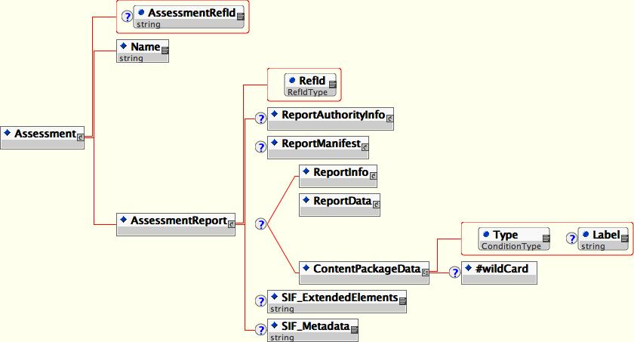

Since its creation the SIF_ReportObject has proven a powerful tool to report data vertically and outside the traditional horizontal object exchange choreography. What has begun to emerge though is that as the scope of SIF encroaches on all parts of the PK-16 data universe it has become apparent that there are use cases that call for expanded capabilities and flexibility on the part of the SIF_ReportObject.

That presented us with a dilemma. We had originally conceived incorporating IMS/ISO Content Package as it is, since it allows Shared Content Objects (from the SCORM standard) and all kinds of binary data, and other instructional objects inside of its structure. However, the lack of name spacing in the SIF infrastructure and the need for GUIDs made that impractical. We also did not want to require vendors, educational institutions, and at least three states to make serious changes because of this new structure.

Therefore we came up with the current design. It is a set of optional extensions to the SIF_ReportObject Design which allows it to be fully compatible with the current choreographies and allows it to be used in a variety of new manners.

Assessment Container Object
Assessment has driven a need for a container object to carry Assessment objects. As SIFA expands more and more into the instructional services domain and with the new commitment by SIFA to move into that space to support direct impact on student achievement, we need to address the issues of moving learning resources, instructional objects and assessment related objects. One of the core use cases in that arena is the delivery of assessment items to the teacher using a learning management system from a data store of items based on certain criteria. This would usually not be delivery of one item at a time but would return a group of items. A SIF_ReportObject is a logical container for such a delivery. Therefore we would need to include:
- Binary files (maps, pictures used by items, etc. )
- Large groups of related Assessment Items and Assessments packaged together
- Other data structures

Here is a visual representation of the enhanced object. Except for the documented changes this object should be related to and operated with as per the 1.5r1 object. Each Task Force and Workgroup may publish an extended Choreography document to specify how these new enhanced features - and some of the old ones - should be used.

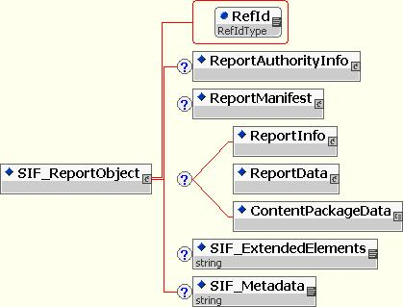

The Assessment container object will be exactly as specified above. Anywhere SIF_ReportObject is mentioned, think Assessment object. The elements described below refer to existing Vertical Reporting objects. See the Vertical Reporting objects specification for more detail.

ReportAuthorityInfo
We have added an optional embedded ReportAuthorityInfo structure.

- The ReportAuthorityInfo element structure is identical in structure to the ReportAuthorityInfo Object structure in SIF v1.5r1.
- This also allows the ReportAuthorityInfo to be identified if the Report is disassembled in an environment where the SIF GUIDs are meaningless. This allows the report to leave its home Zone and maintain the data relationships.
- If there are multiple ReportAuthorities (as there are in some use cases where there is one receiving authority but the individual objects are distributed to other authorities ) then the ReportData payload should include 1 to n other SIF_ReportObjects so as to allow that kind of nested reporting.

ReportManifest
We have added an optional embedded ReportManifest.

- The ReportManifest element structure is identical in structure to the ReportManifest Object structure in SIF v1.5r1 except that it reflects the changes to ReportManifest proposed in the Vertical Reporting Task Force’s document entitled: “VRChanges20060203”
- This also allows the ReportManifest to be identified if the Report is disassembled in an environment where the SIF GUIDs are meaningless. This allows the report to leave its home Zone and maintain the data relationships.
- This also allows the SIF_ReportObject creator to identify the payload to an intermediary so that intermediary can deconstruct the SIF_ReportObject and the GUIDs.

ReportData
The only change to ReportData is a critical one: it must be updated to include all the 2.0 Objects in its choice structure. This is particularly important for Assessment, eTranscript, and the SIS group for Vertical Reporting purposes. Because this list is not yet finalized this document and the XSD do not yet reflected the updated list.

We are recommending the creation of a “Binary Resource Object” of some kind to act as a “Common Object” that can be used to store Binary data when required. However, this object is not described in this document and its creation and explanation is outside the scope of this document.

ContentPackageData
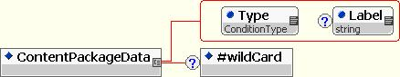

This structure is similar to the ReportData structure except that its payload is non-SIF XML that is recognizable by the receiving agent based on pre-designed contract or acceptable as a glob of data which can then be stored or handed off to an application that can understand it.

The type accepts three values:
- Generic XML: This value indicates that this is a package of XML that does not need to be understood by the agent but merely passed to the ReportingAuthority.
- Named: This indicates that this is XML data of a type that has an understood label between the two Agents. Such a label could be: “PESC XML Transcript v3.9,” or “IMS ePortfolio v2.3,” or even “Bob’s Homegrown XML”. This recognizes that in order to truly approach “out of the box” SIF will need to integrate with the systems that are already there as quickly and as easily. This functionality could be abused but the benefits in terms of being able to deploy quickly in an already existing environment far outweighs our duty of protecting people from themselves.
- IMS Content Package v1.2: This indicates that the contents of the ContentPackageData is a valid, well-formed IMS v1.2 Content Package. This allows for many Assessment Results, Instructional and SCORM objects to be moved in the SIF environment that might not have been able to otherwise.

The “label” attribute carries the name value of the XML type in the ContentPackageData element. It can be null.

SIF_Metadata

Some of the more advanced use cases of the SIF_ReportObject will certainly make use of the SIF_Metadata Common Objects. Please see the Data Model Task Force’s “MetadataCommonElement_ObjectPlan_v0p9” for more details.

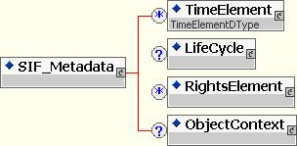

AssessmentAdministration Object

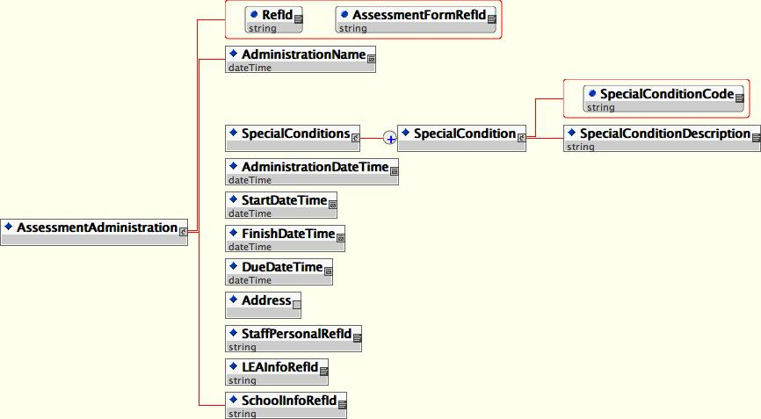

Element or Attribute | SIF Char.  XML Type | Description | Example
AssessmentAdministration | --- | This object represents an assessment event. It includes information related to the time of administration, place of administration, and unusual events related to the administration. SIF events may be reported for this object.
Refid | M  SIF RefId | The Id (GUID) that uniquely identifies an instance of the object. |  | --
AssessmentFormRefId | M  SIF RefId | The RefId of the assessment form used in the assessment administration. |  | --
SpecialConditions | O  [Element] | Special conditions or unusual events related to the administration event. | --
SpecialCondition | MR  [Elements] | One or more special conditions. | --
SpecialConditionCode | M  token | This is the primary key for the list of special conditions. | 25B
SpecialConditionDescription | O  string | A text description of the special condition. | a. Fire drill during test.  b. Air conditioning broke during the test.  c. Assessment was given over three days instead of in one sitting.
AdministrationDateTime | M  SIF DateTime | Date the test is scheduled to be given.  Time the test is scheduled to be given. | 3/6/06  - 1:25 PM  - 13:25
StartDateTime | O  SIF TimeTime | Date testing begins.  Time testing begins. | 3/6/06  - 1:30 PM  - 13:30
FinishDateTime | O  SIF DateTime | Date testing ends.  Time testing ends. | 3/6/06  - 2:47 PM  - 14:27
DueDateTime | O  SIF DateTime | Date test is due. | 3/8/06
Address | O  [SIF Common Element] | Address of the location where the administration takes place. | ---
StaffPersonalRefId | O  RefId | Optional reference to a staff person associated with the administration. | ---
LEAInfoRefId | O  RefId | Optional reference to a school district associated with the administration. | ---
SchoolInfoRefId | O  RefId | Optional reference to a school associated with the administration. | ---

AssessmentForm Object

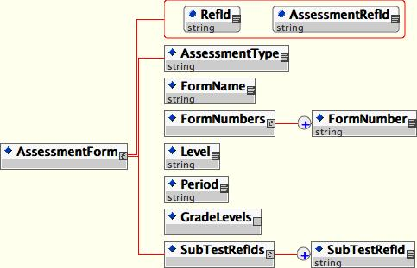

Element or Attribute | SIF  Characteristic | Description | Example
AssessmentForm | --- | Represents the unique set of questions or stimuli given to a set of test takers. A physical correlate of the assessment form is the test booklet given to students during an assessment. However, this object does not contain the questions, it only contains elements that describe the form for use in scoring the questions. SIF events may be reported for this object.
Refid | M  SIF RefId | The Id (GUID) that uniquely identifies an instance of the object. | --
AssessmentRefId | M  SIF RefId | The RefId of the assessment related to this form. | --
AssessmentType | O  token | Indicates whether this assessment (form) is a standard administration or alternate.  Values:  standard  alternate | standard
FormName | M  normalizedString | Text description for this particular arrangement of questions, etc. | Form A
FormNumbers | O  [Elements] | Container for one or more form number elements. | ---
FormNumber | MR  token | One or more reference numbers for the form. This element will use the SIF complete list method for repeatable elements. | 34
Level | O  token | Indicates the level of the form. | - 03 (Grade 3)  - 24 (Leveling system)
Period | O  token | The time period in which the form is intended to be administered. | a. Spring  b. Fall
GradeLevels | O  [Elements] | SIF GradeLevels common element. | ---
GradeLevel | MR  token | One or more grade levels this assessment form is designed to evaluate. | 03 (Grade 3)
SubTestRefIds | O  [Elements] | Container for one or more subtest refids.
SubTestRefId | MR  RefId | One or more associated subtests (score types). Each form can provide scores in one or more subtest areas. This element will use the SIF complete list method for repeatable elements. | ---

AssessmentRegistration Object

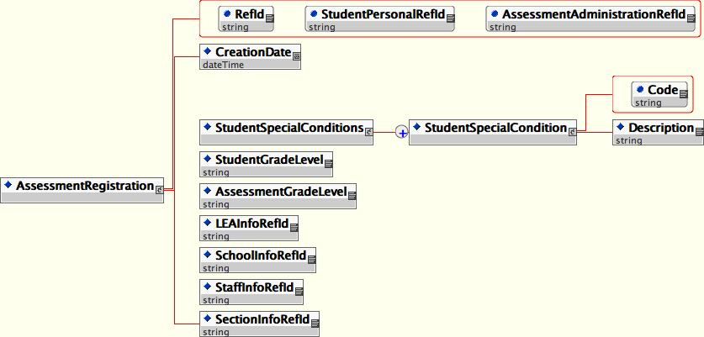

Element or Attribute | SIF  Characteristic | Description | Example
AssessmentRegistration | --- | This object represents the assignment of a specific assessment to be taken by a student. SIF events may be reported for this object.
Refid | M  SIF RefId | The Id (GUID) that uniquely identifies an instance of the object. | --
StudentPersonalRefId | M  SIF RefId | The student associated with the registration. | --
AssessmentAdministrationRefId | M  SIF RefId | The assessment administration associated with the registration. | --
CreationDate | M  SIF DateTime | Date/Time assignment is made. | 03/05/06
StudentSpecialConditions | O  [Elements] | Container for one or more special condition elements.
StudentSpecialCondition | MR | One or more special conditions.
Code | M  token | Records student-specific special conditions during the test. | 45c
Description | O  normalizedString | A description of the special condition. | Student became ill during test
StudentGradeLevel | O  token | Grade level of the student at the time of testing | 04
AssessmentGradeLevel | O  token | The grade or level at which the student is to be tested. This element should be null unless the student is being tested out-of-level. | 03
LEAInfoRefId | O  RefId | Optional reference to a district associated with the registration. | ---
StaffPersonalRefId | O  RefId | Optional reference to a staff person associated with the registration. | ---
SchoolInfoRefId | O  RefId | Optional reference to a school associated with the registration. | ---
SectionInfoRefId | O  RefId | Optional reference to a section (or class) associated with the registration.

AssessmentSubTest Object

A psychological construct measured by the assessment. Operationally, a subtest is a class of scores on an assessment. Some assessments may have only one subtest or type of score but most assessments measure more than one psychological construct. The subtest can be based upon items in a section or items that are empirically related. Subtests can also be composites of other subtests that are combined using a particular algorithm. Examples of subtests of an assessment are math total, reading composite, total test, English composition. SIF_Events are reported.

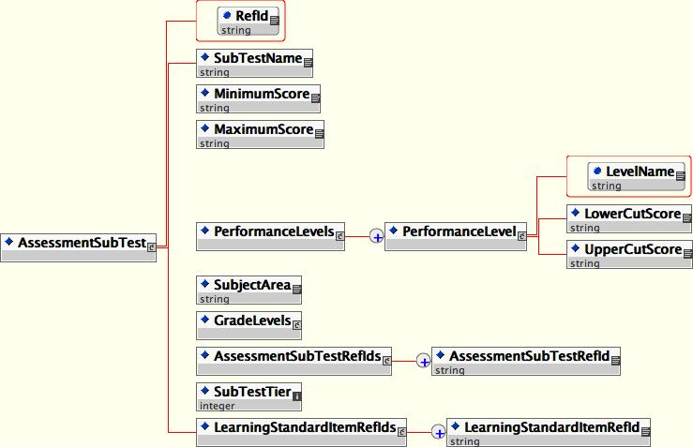

Element or Attribute | SIF  Characteristic | Description | Example
AssessmentSubTest |  | (See definition above). SIF events may be reported for this object.
Refid | M  SIF RefId | The Id (GUID) that uniquely identifies an instance of the object. | --
SubTestName | M  normalizedString | Text name of the subtest.
MinimumScore | O  token | Lowest possible score value. | 0
MaximumScore | O  token | Highest possible score value. | 110
PerformanceLevels | OR  [Elements] | Container for one or more performance level elements. | ---
PerformanceLevel | M  [Elements] | Defines one or more cut scores for placing students in appropriate performance levels. | ---
LowerCutScore | O  token | Lower bound for the performance level. | 25
UpperCutScore | O  token | Upper bound for the performance level. | 50
LevelName | M  token | The name of the performance level. This is the primary key for the list. | Basic
SubjectArea | O  token | Content area covered by the score. | Reading Comprehension
GradeLevels | O  [Elements] | SIF GradeLevels common element. | ---
GradeLevel | MR  token | One or more grade levels for which the score is valid. | 03
AssessmentSubTestRefIds | O  [Elements] | A containter for one or more assessment subtest refids. | ---
AssessmentSubTestRefId | MR  RefId | One or more (recursive) references to other SIF SubTests. This enables subtests or scores to be composites of other scores. If any references are given here, the score is a composite score. The list must be unique. | ---
SubTestTier | O  token | An integer that defines the level or tier of the score in a multi-level arrangement of composite scores. Zero indicates the highest or root level. | 0
LearningStandardItemRefIds | O  [Elements] | A container for one or more learning standard item refids. | ---
LearningStandardItemRefId | MR  RefId | One or more optional references to the SIF Learning Standard Item. The list must be unique. | ---

StudentResponseSet Object

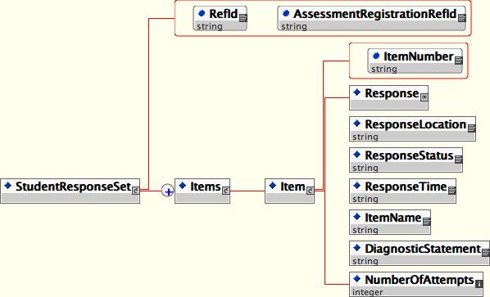

Element or Attribute | SIF  Characteristic | Description | Example
StudentRepsonseSet |  | This object transmits the students’ responses to stimuli presented in an assessment. These are the raw, unscored responses. SIF events may be reported for this object.
Refid | M  SIF RefId | The Id (GUID) that uniquely identifies an instance of the object. | --
AssessmentRegistrationRefId | M  SIF RefId | The registration associated with the response set. | --
Items | M  [Element] | Contains one or more item elements. | --
Item | MR  [Elements] | The item contains response data and metadata for each item. This element will use the SIF complete list method for repeatable elements. | ---
Response | M  string | Answer selected or student work in raw format | - C  - 19
ResponseLocation | O  anyURI | An optional element that contains a URI pointing to the location of the response or additional response. | http://one.two.three  ftp://one.two.three
ResponseStatus | O  token | Status of the response.  Values:  Correct  Incorrect  Complete  PartiallyComplete  Viewed  NotViewed (The item was not viewed by the student)  NotAnswered  Attempted (The item was viewed but no response given)  Incomplete | Incomplete  Correct
ResponseTime | O  SIF Time | The length time the student took to respond. | 2:47 (Two minutes, 47 seconds)
ItemNumber | O  token | Identifies the item on the assessment by number. | 27
ItemName | O  token | Identifies the item on the assessment by name. | Writing Sample 1
DiagnosticStatement | O  string | Psychometric purpose or design-related comment about the question. | Student shows ability to determine symmetry.
NumberOfAttempts | O  integer | The number of times a student changes their answer or attempts a response. | 2

StudentScoreSet Object

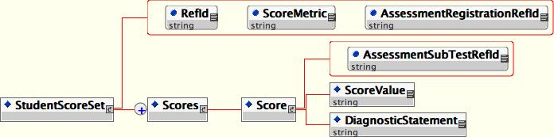

Element or Attribute | SIF  Characteristic | Description |  | Example
StudentScoreSet | --- | The scored results from an assessment. SIF events may be reported for this object.
Refid | M  SIF RefId | The Id (GUID) that uniquely identifies an instance of the object. | --
ScoreMetric | M  (Coded) | The metric or scale used to report the score.  Code set:  NCES Handbook  0056 – Assessment Reporting Method
AssessmentRegistrationRefId | M  SIF RefId | The registration associated with this score set. | --
Scores | M  [Elements] | Contains on or more score elements. |  | --
Score | MR  [Elements] | The score with other information related to the score. |  | ---
AssessmentSubTestRefId | M  RefId | References the SIF SubTest that defines the score. This is the primary key for the set (list). |  | ---
ScoreValue | M  string | The value of the score. |  | 25
DiagnosticStatement | O  string | Comment created by any logical analysis of this score. |  | Student demonstrates ability to identify symmetry.

XML Schema

XML Schema are published in a separate document.

XML Examples

Assessment Object

AssessmentAdministration Object
<AssessmentAdministration xmlns:xsi = "http://www.w3.org/2001/XMLSchema-instance" RefId = "string" AssessmentFormRefId = "string" xsi:noNamespaceSchemaLocation = "AssessmentAdministration.xsd">
<SpecialConditions>
<!--(SpecialCondition+)-->
<SpecialCondition>
<!--(SpeicalConditionCode , SpecialConditionDescription)-->
<SpeicalConditionCode>25B</SpeicalConditionCode>
<SpecialConditionDescription>Fire drill during test.</SpecialConditionDescription>
</SpecialCondition>
</SpecialConditions>
<AdministrationDate>20060306</AdministrationDate>
<AdministrationTime>14:30:00</AdministrationTime>
<StartDate>20060306</StartDate>
<StartTime>14:30:00</StartTime>
<FinishDate>20060306</FinishDate>
<FinishTime>15:30:00</FinishTime>
<DueDate/>
<Address/>
<StaffPersonalRefId/>
<LEAInfoRefId/>
<SchoolInfoRefId/>
</AssessmentAdministration>

AssessmentForm Object
<AssessmentForm xmlns:xsi = "http://www.w3.org/2001/XMLSchema-instance" RefId = "string" AssessmentRefId = "string" xsi:noNamespaceSchemaLocation = "AssessmentForm.xsd">
<AssessmentType>standard</AssessmentType>
<FormName>Form A</FormName>
<FormNumbers>
<!--(FormNumber+)-->
<FormNumber>34</FormNumber>
</FormNumbers>
<Level>03</Level>
<Period>Spring</Period>
<GradeLevels/>
<SubTestRefIds>
<!--(SubTestRefId+)-->
<SubTestRefId>string</SubTestRefId>
</SubTestRefIds>
</AssessmentForm>

AssessmentRegistration Object
<AssessmentRegistration xmlns:xsi = "http://www.w3.org/2001/XMLSchema-instance" RefId = "string" StudentPersonalRefId = "string" AssessmentAdministrationRefId = "string" xsi:noNamespaceSchemaLocation = "AssessmentRegistration.xsd">
<CreationDate/>
<StudentSpecialConditions>
<!--(StudentSpecialCondition+)-->
<StudentSpecialCondition>
<!--(Code , Description)-->
<Code>45C</Code>
<Description>Student became ill during test.</Description>
</StudentSpecialCondition>
</StudentSpecialConditions>
<StudentGradeLevel>04</StudentGradeLevel>
<AssessmentGradeLevel>03</AssessmentGradeLevel>
<LEARefId>string</LEARefId>
<SchoolInfoRefId>string</SchoolInfoRefId>
<StaffInfoRefId>string</StaffInfoRefId>
<SectionInfoRefId>string</SectionInfoRefId>
</AssessmentRegistration>

AssessmentSubTest Object
<AssessmentSubTest xmlns:xsi = "http://www.w3.org/2001/XMLSchema-instance" RefId = "string" xsi:noNamespaceSchemaLocation = "AssessmentSubTest.xsd">
<MinimumScore>0</MinimumScore>
<MaximumScore>110</MaximumScore>
<PerformanceLevels>
<!--(PerformanceLevel+)-->
<PerformanceLevel>
<!--(LowerCutScore , UpperCutScore , LevelName)-->
<LowerCutScore>25</LowerCutScore>
<UpperCutScore>50</UpperCutScore>
<LevelName>Basic</LevelName>
</PerformanceLevel>
</PerformanceLevels>
<SubjectArea>Reading Comprehension</SubjectArea>
<GradeLevels>
<!--(GradeLevel+)-->
<GradeLevel>03</GradeLevel>
</GradeLevels>
<AssessmentSubTestRefIds>
<!--(AssessmentSubTestRefId+)-->
<AssessmentSubTestRefId>string</AssessmentSubTestRefId>
</AssessmentSubTestRefIds>
<SubTestTier>0</SubTestTier>
<LearningStandardItemRefIds>
<!--(LearningStandardItemRefId+)-->
<LearningStandardItemRefId>string</LearningStandardItemRefId>
</LearningStandardItemRefIds>
</AssessmentSubTest>

StudentResponseSet Object
<StudentResponseSet xmlns:xsi = "http://www.w3.org/2001/XMLSchema-instance" RefId = "string" AssessmentRegistrationRefId = "string" xsi:noNamespaceSchemaLocation = "StudentResponseSet.xsd">
<!--(Item+)-->
<Item>
<Response>C</Response>
<ResponseLocation>http://one.two.three</ResponseLocation>
<ResponseStatus>Incomlete</ResponseStatus>
<ResponseTime>00:00:32</ResponseTime>
<ItemNumber>27</ItemNumber>
<ItemName>Writing Sample 1</ItemName>
<DiagnosticStatement>Shows ability to determine symmetry</DiagnosticStatement>
<NumAttempts>2</NumAttempts>
</Item>
</StudentResponseSet>

StudentScoreSet Object
<StudentScoreSet xmlns:xsi = "http://www.w3.org/2001/XMLSchema-instance" RefId = "string" ScoreMetric = "string" AssessmentRegistrationRefId = "string" xsi:noNamespaceSchemaLocation = "StudentScoreSet.xsd">
<!--(Score+)-->
<Score AssessmentSubTestRefId = "string">
<ScoreValue>25</ScoreValue>
<DiagnosticStatement>Shows ability to identify symmetry.</DiagnosticStatement>
</Score>
</StudentScoreSet>

Time Line

Date | Milestone | Notes | Object Approval Step
Oct. 15 | Object Proposal Submitted | The term Object Proposal is new. | 1
Nov. 1 | Executive Director Approval | Approval is of the Object Proposal. | 2
Nov. 3-4 | Tech Board Retreat | Review Object Proposals
Feb. 22 | Object Plan Complete | This must be at least 30 days after Step 1. | 3
March 23 – April 22 | 30-day Object Plan Review | Review by Tech Board and SIF membership. | 4
April 22 | Objects Achieve Draft Status | This happens via Tech Board endorsement or via no action from the Tech Board. Must be after Step 4.
March 28 | Test Plan Submitted |  | 5
April 15 | Alpha Testing complete and Final Testing Document Submitted. |  | 6
April 25 | Objects Achieve Pending Status | This happens via Tech Board endorsement. | 7
May 1 | Board of Directors Approval
May 5- June 5 | 30-Day Specification Review | Review by SIF membership. | 8
June 6-10 | 5-day Specification Adjustment and Final Editing. | Based upon comments from Step 8.
June 11-15 | 5-day Voting Period | SIF membership votes to approve the specification.
June 15 | The Specification becomes Final
 | Public Comment Period | These comments will be addressed in a future release.

Appendix A: XML Diagram Symbol

Appendix B: SIF Characteristic Codes

Characteristic codes for elements/attributes are:
M | Mandatory Element/Attribute
O | Optional Element
C | Conditional Element
MR | Mandatory & Repeatable Element
OR | Optional & Repeatable Element
CR | Conditional & Repeatable Element

Appendix C: XML Data Types:

Here are some XML data types that may be used in the assessment objects:

Primitive Types
- string
- normalizedString (string without carriage returns, line feeds or tabs)
- token (normalized string without leading or trailing spaces and no internal sequences of two or more spaces)
- integer
- unsigned/positive integer
- decimal
- unsigned/positive decimal
- anyURI
- base64Binary
- Boolean: true, false or 1, 0
- dateTime:
'-'? yyyy '-' mm '-' dd 'T' hh ':' mm ':' ss ('.' s+)? (zzzzzz)?

where

zzzzzz = (('+' | '-') hh ':' mm) | 'Z'

(canonical representation cannot have hh = 24, or fractional seconds with trailing zeros, and time zones must be Z (UTC))
- date:
'-'? yyyy '-' mm '-' dd zzzzzz?

(canonical representation of time-zoned values has the time zone Z (UTC))

- time
hh ':' mm ':' ss ('.' s+)? (zzzzzz)?

(canonical representation omits the time zone or has the time zone Z (UTC))

SIF Types
- RefId
- Date (YYYYMMDD)
- Year (YYYY)
- Time (HH:MM:SS)

SIF Characteristic. See Appendix B for the list of Codes.
See Appendix C for a list of XML types.
Elements of type [Element] contain other xml elements.

